**DAILY ONLINE ACTIVITIES SUMMARY**

|  |  |  |  |  |  |  |  |  |
| --- | --- | --- | --- | --- | --- | --- | --- | --- |
| **Date:** | **27/05/2020** | | | | | **Name:** | **NAIPUNYA VINOD NAIK** | |
| **Sem & Sec** | **IV SEM & A SECTION** | | | | | **USN:** | **4AL18CS050** | |
| **Online Test Summary** | | | | | | | | |
| **Subject** | | **OBJECT ORIENTED CONCEPTS** | | | | | | |
| **Max. Marks** | | **30** | | **Score** | | | **30** | |
| **Certification Course Summary** | | | | | | | | |
| **Course** | **INTRODUCTION TO CLOUD COMPUTING** | | | | | | | |
| **Certificate Provider** | | | **Cognitive.ai with IBM** | | **Duration** | | | **6 HRS** |
| **Coding Challenges** | | | | | | | | |
| **Problem Statement:1)** [In Bubble sort, each pass consists of comparison each element in the file with its successor (i.e. x[i] with x[i+1]) and interchanging two elements if they are not in the proper order. The array may be sorted in any pass. If the array is sorted, then remaining passes should be skipped off. Write a C Program to sort an array of integers in ascending order and display the sorted array and Number of passes performed for sorting.](https://github.com/orgs/alvas-education-foundation/teams/2nd-year/discussions/83)  2) [Given an array arr[] of the positive integers of size N, the task is to find the largest element on the left side of each index which is smaller than the element present at that index. Note: If no such element is found then print -1.](https://github.com/orgs/alvas-education-foundation/teams/2nd-year/discussions/82) | | | | | | | | |
| **Status: EXECUTED** | | | | | | | | |
| **Uploaded the report in Github** | | | | | **YES** | | | |
| **If yes Repository name** | | | | | <https://github.com/naipunya-naik/lockdown-coding/blob/master/C%20CODING/bubblesort.c>  <https://github.com/naipunya-naik/lockdown-coding/blob/master/C%2B%2B%20CODING/Positiveinteger.cpp> | | | |
| **Uploaded the report in slack** | | | | | **YES** | | | |

Online Test Details: (Attach the snapshot and briefly write the report for the same)

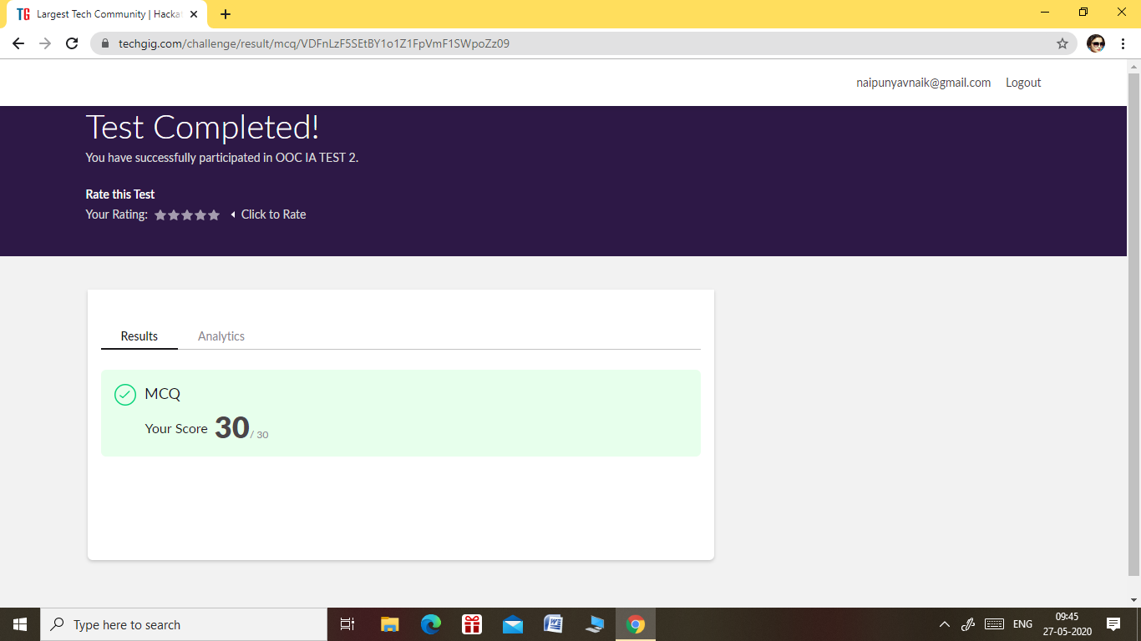

* THE 2ND I.A TEST OF SUBJECT OBJECT ORIENTED PROGRAMMING WAS CONDUCTED ON 27 MAY 2020.
* SUBJECT :- OBJECT ORIENTED CONCEPTS
* NO.OF QUESTIONS:- 30
* DURATION:-30 MIN
* START TIME:-9.15 AM
* END TIME:- 9.45 AM
* EACH QUESTION CARRIED 1 MARK

Certification Course Details: (Attach the snapshot and briefly write the report for the same).

CERTIFICATION COURSE NAME: INTRODUCTION TO CLOUD COMPUTING



* TOPICS COVERED:-

### MODULE 1: Module 1 - Overview of Cloud Computing

1. Module 2 - Cloud Adoption and Emerging Technologies
2. .Module 3 - Cloud Computing Service and Deployment Models

Coding Challenges Details: (Attach the snapshot and briefly write the report for the same)

PROBLEM STATEMENT 1:- [In Bubble sort, each pass consists of comparison each element in the file with its successor (i.e. x[i] with x[i+1]) and interchanging two elements if they are not in the proper order. The array may be sorted in any pass. If the array is sorted, then remaining passes should be skipped off. Write a C Program to sort an array of integers in ascending order and display the sorted array and Number of passes performed for sorting.](https://github.com/orgs/alvas-education-foundation/teams/2nd-year/discussions/83)

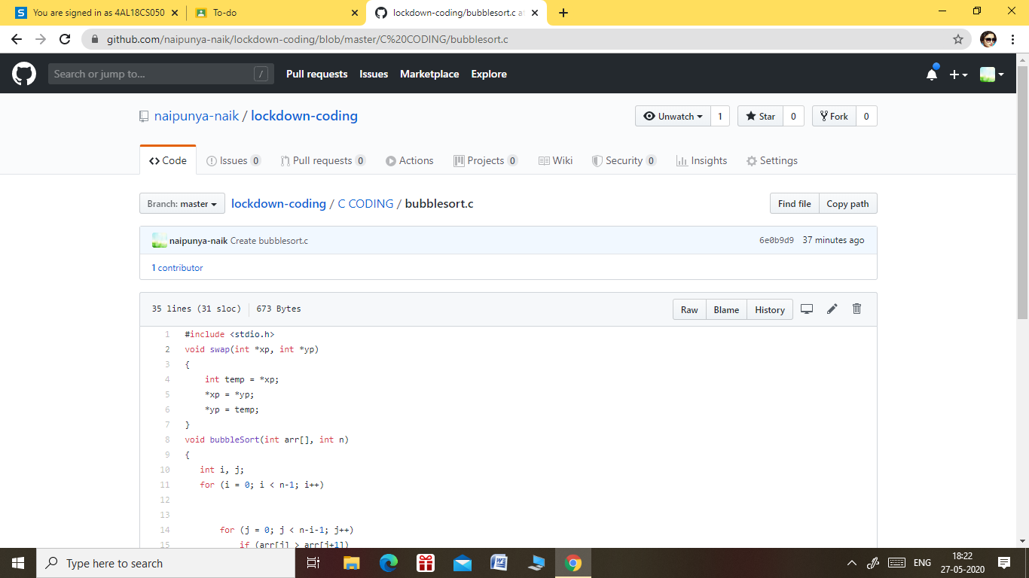

GITHUB REPOSITORY LINK:-

<https://github.com/naipunya-naik/lockdown-coding/blob/master/C%20CODING/bubblesort.c>

PROBLEM STATEMENT 2:- [Given an array arr [] of the positive integers of size N, the task is to find the largest element on the left side of each index which is smaller than the element present at that index. Note: If no such element is found then print -1.](https://github.com/orgs/alvas-education-foundation/teams/2nd-year/discussions/82)

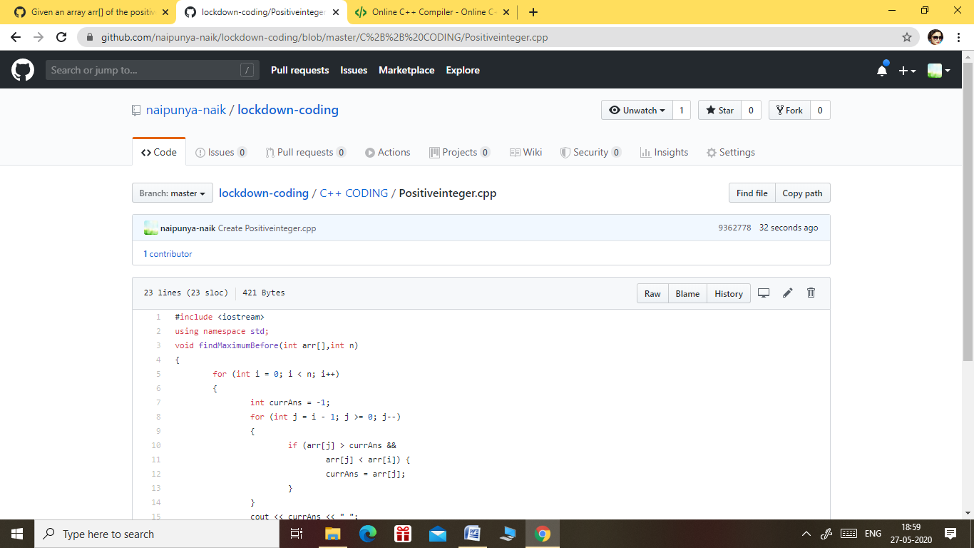

GITHUB REPOSITORY LINK:-

<https://github.com/naipunya-naik/lockdown-coding/blob/master/C%2B%2B%20CODING/Positiveinteger.cpp>